GOOGLE EARTH MEASUREMENTS
Measurements
Why do you want to measure? You can measure a fence line, boundary lines, paddock or a patch of forest, or a section of that patch of forest, the diameter of a dam, sheds etc. This tool is found in the Measures section of the top tool bar (see below). You can measure straight, or meandering lines, polygon measures the ha/m2, or even a circular measurement.
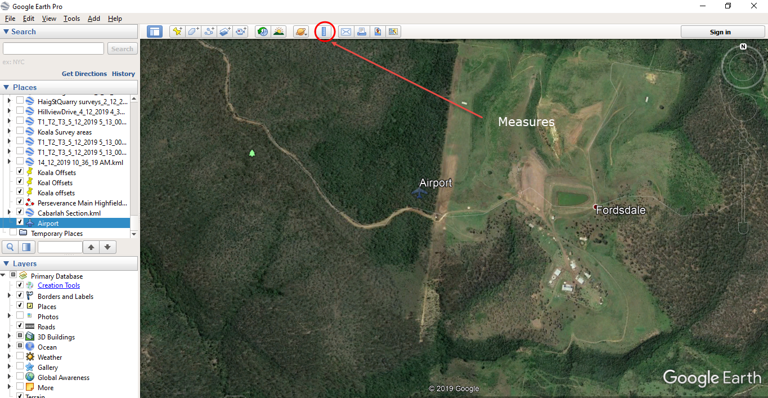

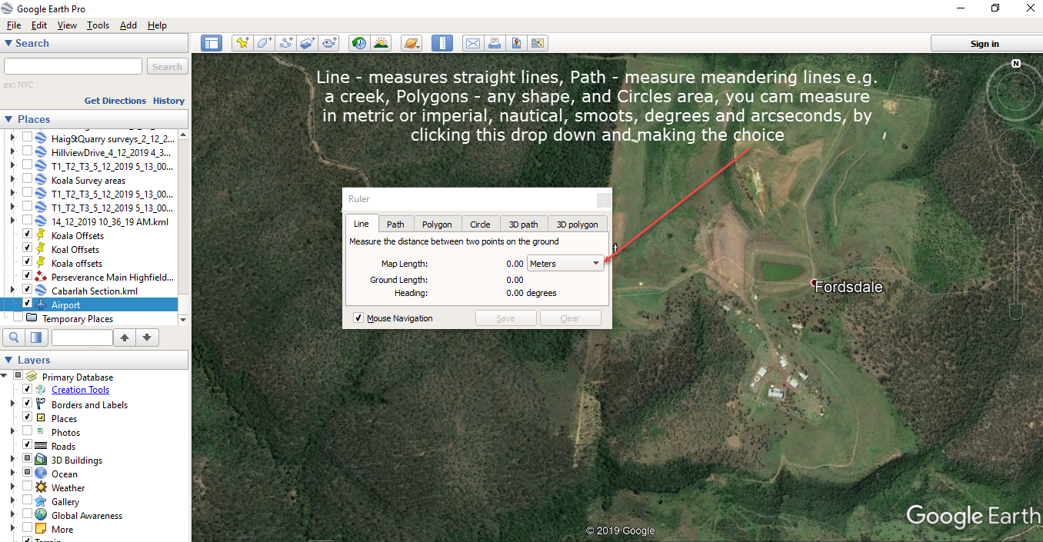

- After clicking the Ruler (Measure), you can then choose what type of measuring you require, Line, Path, Polygon, Circle, clicking on the down arrow with generate a drop down box with a great choice of measurement units, cm, m, km, miles, feet, yards, nautical miles, smoots. Smoot meaning - The smoot /ˈsmuːt/ is a nonstandard, humorous unit of length created as part of an MIT fraternity prank. It is named after Oliver R. Smoot, a fraternity pledge to Lambda Chi Alpha, who in October 1958 lay down repeatedly on the Harvard Bridge (between Boston and Cambridge, Massachusetts) so that his fraternity brothers could use his height to measure the length of the bridge
Line – click to start and click to finish for straight line measurement. Path – click to start, and click at each change of direction e.g. to measure a square, rectangle, triangle, or a road, a creek or a wandering edge of a forest. Polygon – Click at every point of direction change. Circle – click and hold and drag until the circle is the size you require. After all of these measurements if you want to keep them you must click save or cancel (see below).

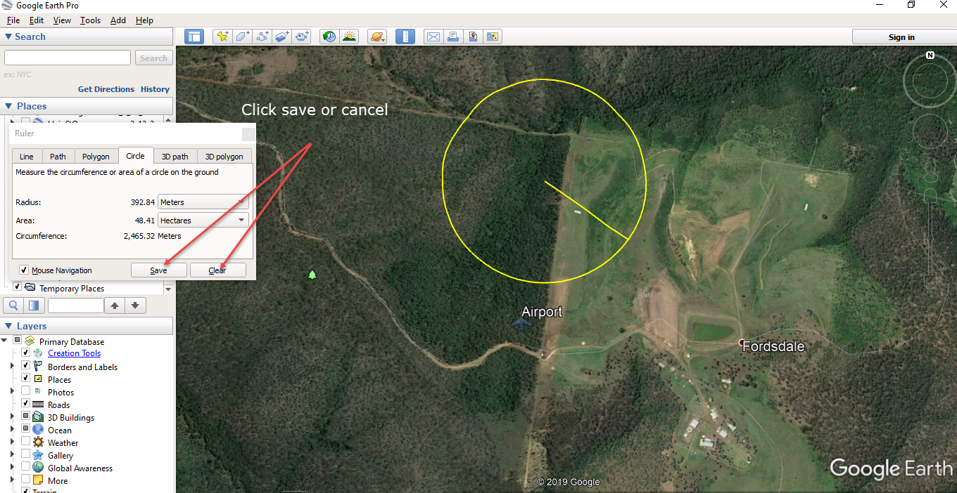

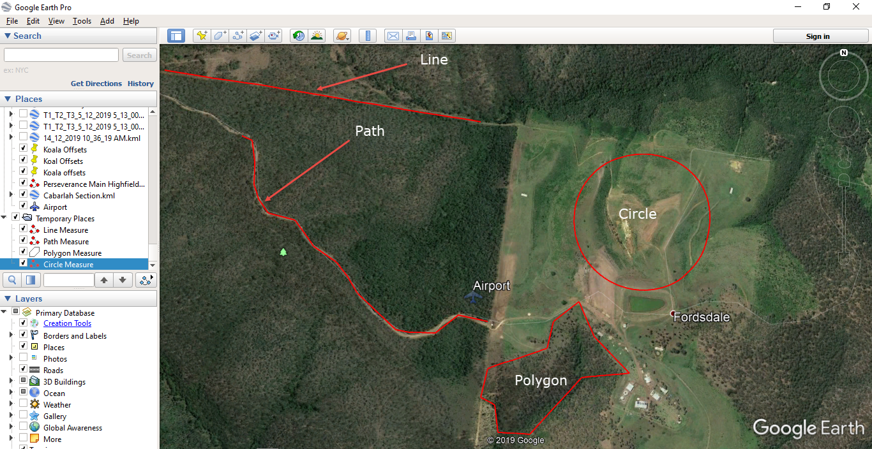
Examples of measurements.

