GOOGLE EARTH KML FILES
Creating a KML file
A KML file is a file that can be opened on Google Earth. A KML can be a Placemark, or a Polygon that you have already saved to your Google Earth. You can convert a Polygon or Placemark into a KML file and email it to someone so they in turn can use it on their Google Earth.
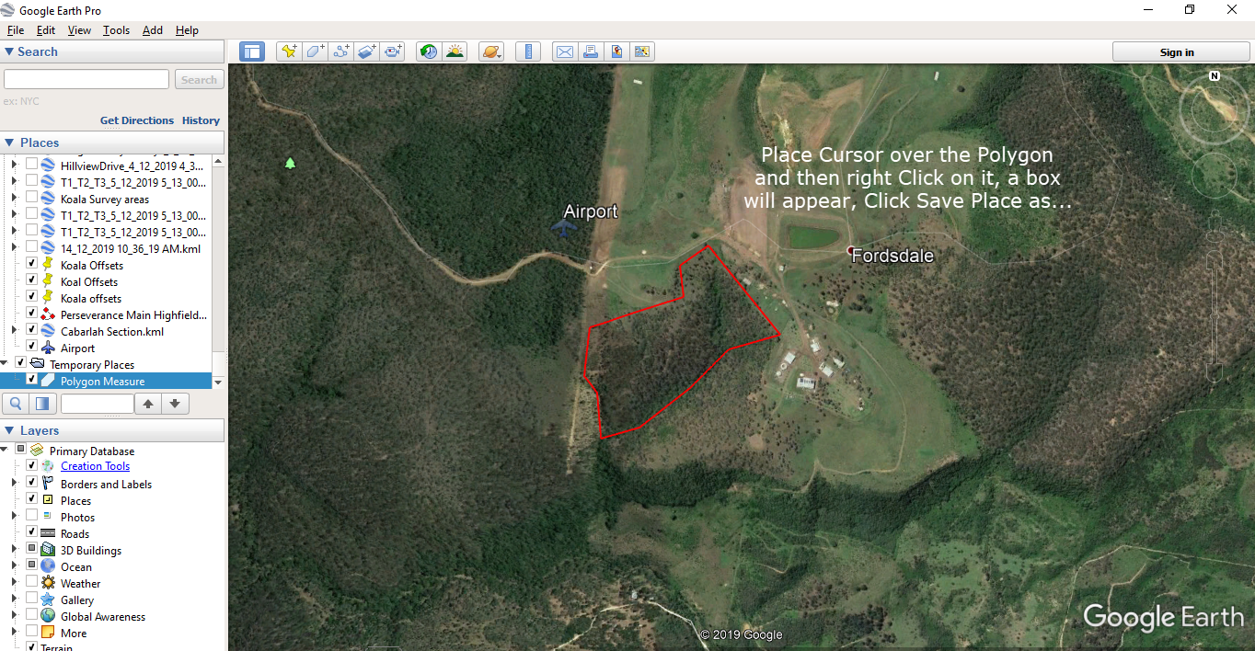
- Save a Polygon as a KML - Place Cursor over the Polygon and then right Click on it, a box will appear, Click Save Place as...

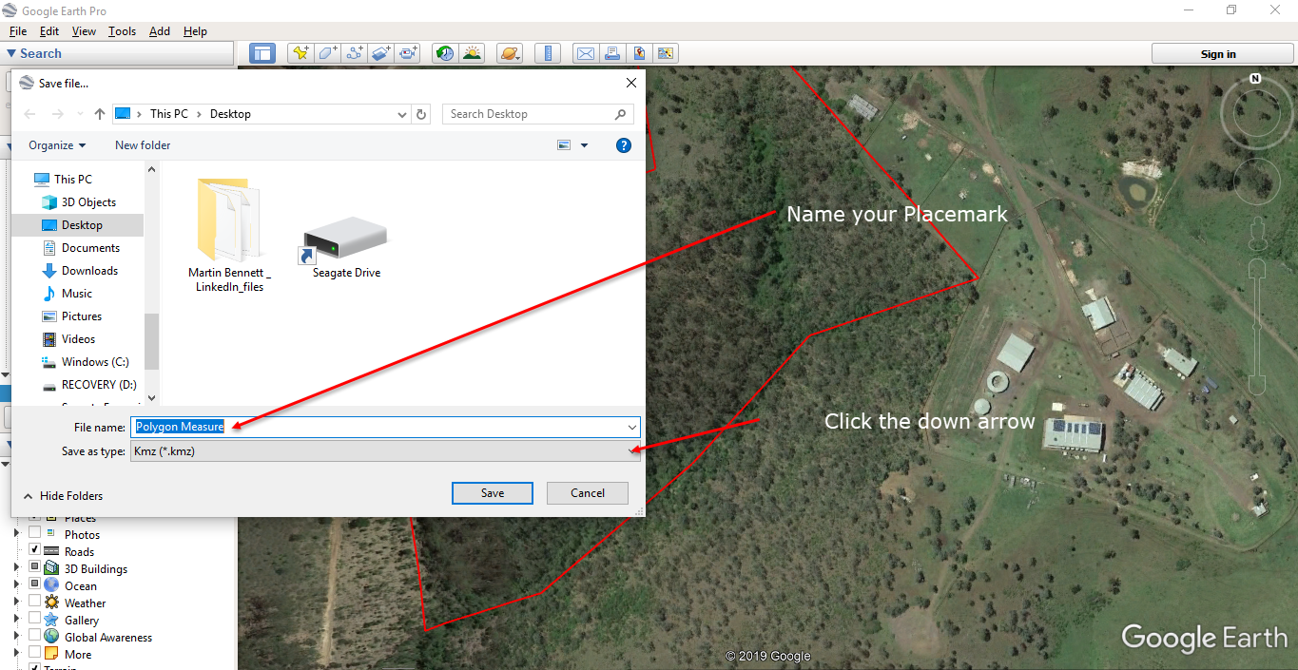
- Name your Placemark – Click the down arrow.

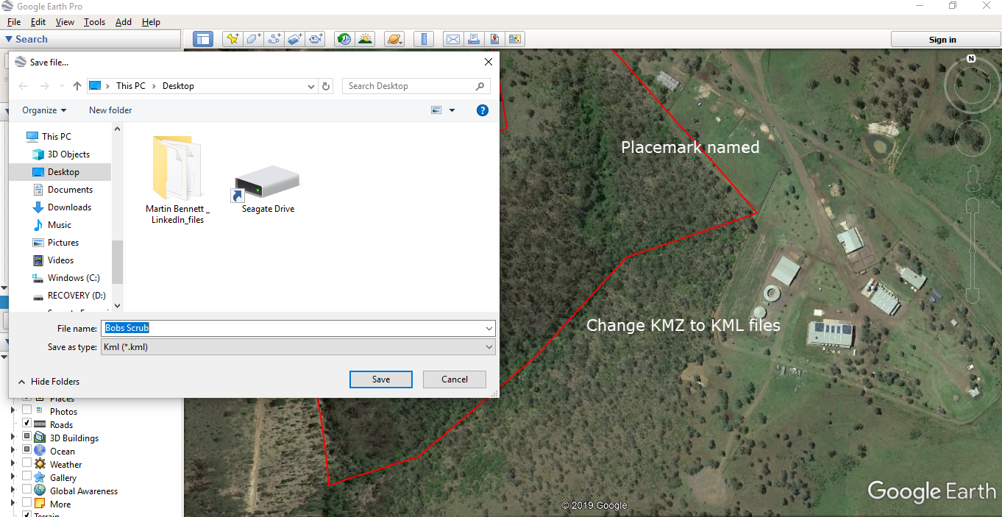
- Placemark re-named, change KMZ file to KML file, and save to Desktop or folder, it is now a KML File with a Google Earth Icon. The KML file can be edited, changed and even converted to another file e.g. Shape Files.

Saving a Placemark as a KML file.
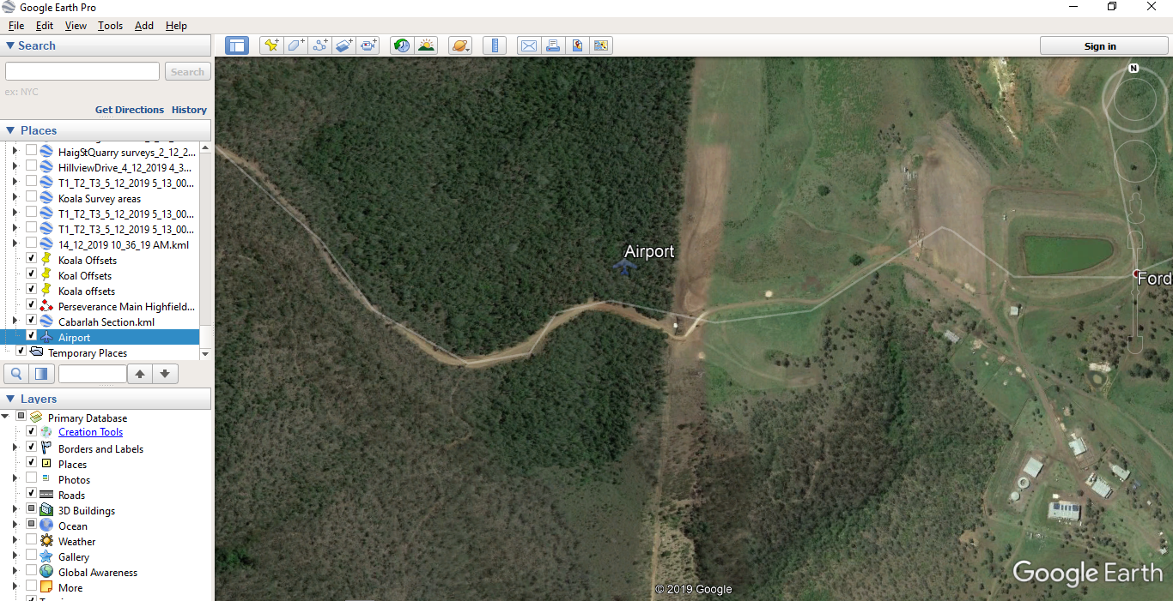
- This is the same process as saving a Polygon as a KML file.

